CHAPTER 1
SYNOPSIS
Title: - Jobster: Connecting Jobs to Seekers
Introduction: - Jobster is a job portal based application where various job seekers and recruiters can connect to each other and apply/share jobs based on respective fields of interest. As the tagline goes, the motive is to let seekers connect to their dream jobs based on their interests. The Application lets the seekers to build up their profile and search for vacancies on the platform as well as provides the recruiters with the opportunity to add, build up their company's profile and share vacancies. However, both of these services requires the user to sign-up and provide up with relevant details before accessing above facilities.
Objectives: - The main objective is to let the seekers search and apply for their dream jobs in an easy and efficient manner. Mainly this idea was derived from naukri.com where multiple users from all over the world search for variety of jobs. However, the only limitation is the lack of interaction between the two entities which leads to an inactive and inefficient mechanism. So, thus here on Jobster, seekers can easily sign-up and apply for their dream jobs which is even simple and clear to go through. Moreover, the Employers can have an interaction with the seekers if their profile interests them.
Pros / Advantages: -
- Provides instant access to variety of vacancies.
- Reduces tedious work for searching due to availability of variety of filters and is convenient for users.
- Provides quick access and is easy to use.
- The system saves time and reduces human efforts.
- Secure System data processing and handling.
Cons / Disadvantages: -
- Offline mode is not supported.
- Not all variety of jobs shall be available, depends directly on organizations of Recruiters registering in the application.
- Database Operations require considerable amount of time to process requests due to entire database operations being processed via Online SQL Server.
- Lack of searching filters based on other parameters at the moment.
FEATURES OF THE PROJECT
- High level of abstraction
- Efficient Performance
- Platform Independence
- Re-usability
- Session handling
- Attractive GUI
- Comprehensive Online Database

CHAPTER 2
REQUIREMENT ANALYSIS
2.1 FEASIBILITY STUDY
Feasibility Study means the analysis of problem to determine if It can be solved effectively. In other words, it is the study of the possibilities of the proposed system it studies the work ability, impact on the organization ability to meet user’s need and efficient use of resources.
Three aspects in which the system has to be feasible are: -
1. ECONOMICAL FEASIBILITY:
The economic analysis checks for the high investment incurred on the system. It evaluates development & implementing charges for the proposed Project. The S/W used for the development is easily available at minimal cost & the database applied is freely available hence it results in low cost implementation.
2 TECHNICAL FEASIBILITY:
This aspect concentrates on the concept of using Computer Meaning, “Mechanization” of human works. Thus, the automated solution leads to the need for a technical feasibility study.
The focus on the platform used database management & users for that S/W.
The proposed system doesn’t require an in-depth technical knowledge as the system development is simple and easy to understand. The S/W used makes the system user friendly (GUI). The result obtain should be true in the real time conditions.
3. BEHAVIOURAL FEASIBILITY:
Behavioral feasibility deals with the run time performance of the S/W the proposed system must score higher than the present in the behavioral study. The S/W should have end user in mind when the system is designed while designing S/W the programmer should be aware of the conditions user’s knowledge input, output, calculations etc.
The S/W contains only a minimum no. of bugs. Care is also taken to avoid non-working means & buttons.
2.2 SOFTWARE REQUIREMENT SPECIFICATION DOCUMENT
A Software Requirements Specification (SRS) is a document that describes the nature of a project, software or application. In simple words, an SRS document is a manual of a project provided it is prepared before starting a project/application. This document is also known by the names SRS report, software document. A software document is primarily prepared for a project, software or any kind of application.
- Introduction: The project titled as “Jobster: Connecting Jobs to Seekers” will be developed using Spring MVC, and MySQL. The aim is to build an application that can be used to search and apply for jobs in an efficient and easy to use manner.
- Requirements:
1. Functional Requirements:
- Authentication:
- Sign In- The user can log in to the application with his/her username which would be the user’s mail id and password.
- Logout- The user can log out from the system very easily and will be redirected to login page. It would be ensured that the user’s activity remains secured after successful Sign Out.
- Login failure- Login error will be there if the user does not exist in the database.
- Data Processing by Job Seekers
  - Job Seekers can add their information, additional details to complete their profile. Once, the profile is completed they can search for the desired job.
  - Job Seeker can search for their desired vacancy/job based on filters like language and location.
- Data Processing by Recruiters
  - Recruiters can add, build up their company/organization's Profile and add Vacancies.
  - Recruiters can also the information of job seekers who have applied for the specified job/vacancy.
2. Non - Functional Requirements:

- Performance requirements: There is no restriction on the number of users to be added to the database.
- Hardware requirements: This application should be able to work on a computer with the following minimum hardware.
- Intel core-2-duo or equivalent or above
- 4 GB RAM or above
- Hard-Disk 500GB or above.
- Software requirements: Platform Independent Desktop Application operating on top of Java Architecture.
- JDK (Java Development Toolkit)
- JRE (Java Run-time Environment)
- Database: MySQL
- Front-end: HTML + CSS + JavaScript + jQuery + Bootstrap
- Programming Language: Java
- Framework: Spring MVC + Spring Security
- Eclipse IDE (STS)

Usability: Usability is the ease of use and learn-ability of a human-made object such as a tool or device.
In software engineering, usability is the degree to which software can be used by specified consumers to achieve quantified objectives with effectiveness, efficiency, and satisfaction in a quantified context of use.
In this case, the application is totally user-friendly and easy to operate.

2.3 SDLC MODEL USED
In a practical software development project, the classical waterfall model is hard to use. So, Iterative waterfall model can be thought of as incorporating the necessary changes to the classical waterfall model to make it usable in practical software development projects. It is almost same as the classical waterfall model except some changes are made to increase the efficiency of the software development.
The iterative waterfall model provides feedback paths from every phase to its preceding phases, which is the main difference from the classical waterfall model.

CHAPTER 3
SYSTEM DESIGN

3.1 PRODUCT PERSPECTIVE
The project titled as “Jobster” will be developed using Spring MVC, Spring Security and MySQL. The aim is to build an application that can be used to search as well as apply for jobs in an easy and efficient manner.
3.2 PRODUCT FUNCTIONS
Once the user signs up in the application, based upon the selected role, next page is delivered for letting the user fill up the additional information. For Job Seekers, the next web-page is to fill up their additional details and complete their profile. While, for the recruiters the next web-page is to add/fill up information for their organization. Once the information is saved, the recruiter can access the feed using which he/she can add up the vacancies on behalf of their organization. While the job seekers can search for their desired job using a set of filters in their respective feed.
3.3 USER CHARACTERISTICS
The System processes data over secure channel exhibiting both authentication and authorization. The User credentials are saved in encrypted manner using SHA.
3.4 CONSTRAINTS
There are basically 3 constraints in database/table associated with this application:
a. email/username
b. password
c. Role

  - Data flow diagrams: -
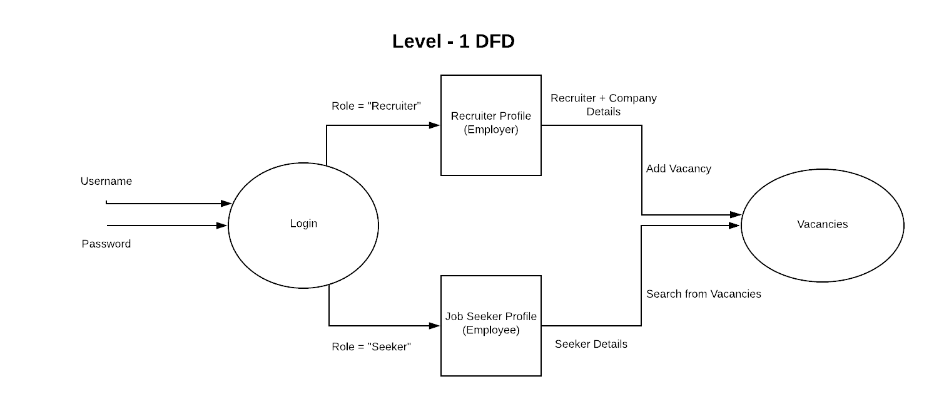
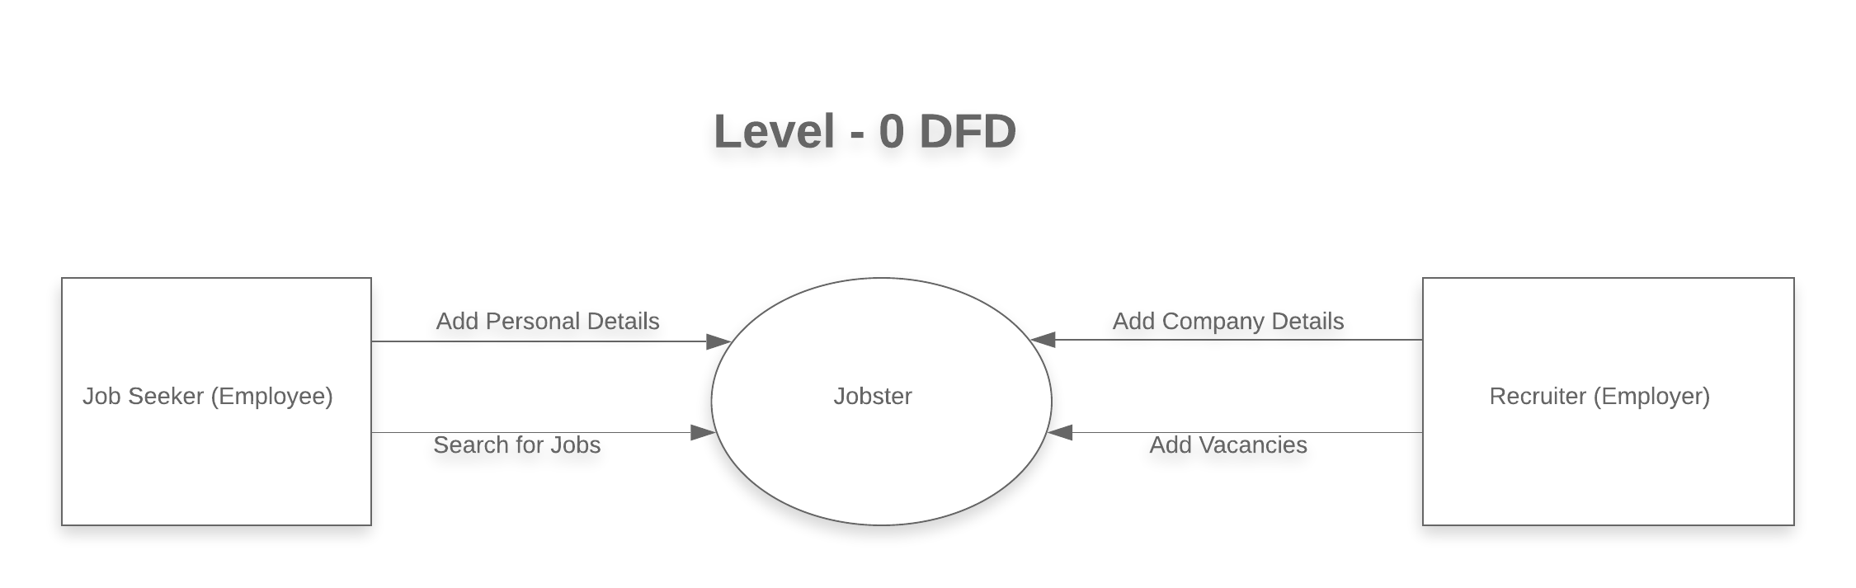
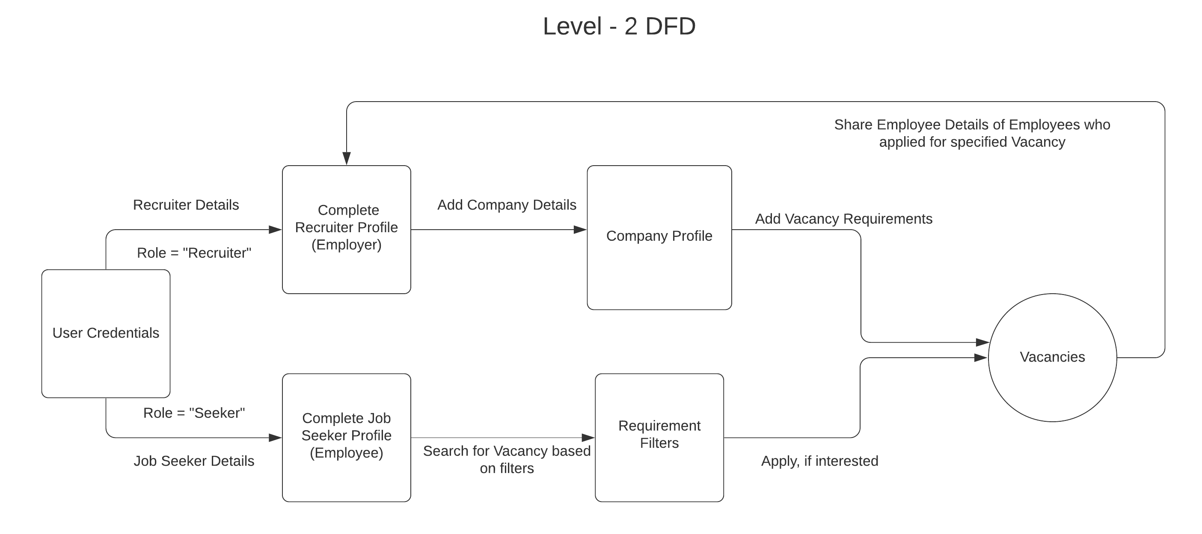
3.6 ER Diagram
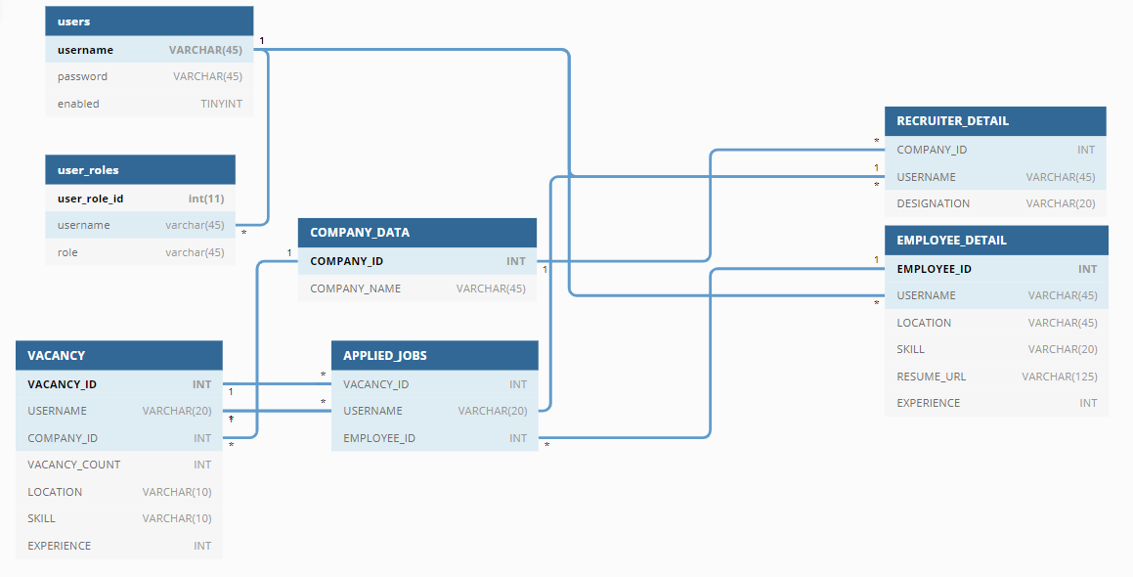
3.7 SPECIFIC REQUIREMENTS
There are no specific requirements as such associated with this application. However, the user needs to be connected to Internet to login.

CHAPTER 4
DEVELOPMENT AND TESTING
4.1 DEVELOPMENT ENVIRONMENT
- JDK (Java Development Toolkit)
- JRE (Java Runtime Environment)
- Database: MySQL
- Front-end: HTML + CSS + BOOTSTRAP
- Framework: Spring MVC + Spring Security
- Programming Language: Java
- IDE: Spring Tool Suite
4.2 SUPPORTING LANGUAGES/TOOLS
- Remote MYSQL
4.3 Testing
Testing is a process of executing a program with the aim of finding error. To make our software perform well it should be error free. If testing is done successfully it will remove all the errors from the software.

Principles of Testing:-
(i) All the test should meet the customer requirements
(ii) To make our software testing should be performed by third party
(iii) Exhaustive testing is not possible. As we need the optimal amount of testing based on the risk assessment of the application.
(iv) All the test to be conducted should be planned before implementing it
(v) Start testing with small parts and extend it to large parts.

Types of Testing:-

1. Unit Testing
It focuses on smallest unit of software design. In this we test an individual unit or group of inter related units.It is often done by programmer by using sample input and observing its corresponding outputs.
Example:
a) In a program we are checking if loop, method or
function is working fine
b) Misunderstood or incorrect, arithmetic precedence.
c) Incorrect initialization

2. Integration Testing
The objective is to take unit tested components and build a program structure that has been dictated by design.Integration testing is testing in which a group of components are combined to produce output.
Integration testing is of four types: (i) Top down (ii) Bottom up (iii) Sandwich (iv) Big-Bang
Example
(a) Black Box testing:- It is used for validation.
In this we ignores internal working mechanism and
focuses on what is the output?.

(b) White Box testing:- It is used for verification.
In this we focus on internal mechanism i.e.
how the output is achieved?

3. Regression Testing
Every time new module is added leads to changes in program. This type of testing make sure that whole component works properly even after adding components to the complete program.
Example
In school record suppose we have module staff, students
and finance combining these modules and checking if on
integration these module works fine is regression testing

4. Smoke Testing
This test is done to make sure that software under testing is ready or stable for further testing
It is called smoke test as testing initial pass is done to check if it did not catch the fire or smoked in the initial switch on.
Example:
If project has 2 modules so before going to module
make sure that module 1 works properly

5. Alpha Testing
This is a type of validation testing.It is a type of acceptance testing which is done before the product is released to customers. It is typically done by QA people.
Example:
When software testing is performed internally within
the organization

6. Beta Testing
The beta test is conducted at one or more customer sites by the end-user of the software. This version is released for the limited number of users for testing in real time environment
Example:
When software testing is performed for the limited
number of people

7. System Testing
In this software is tested such that it works fine for different operating system.It is covered under the black box testing technique.
Example:
This include functional as well as non functional
testing

8. Stress Testing
In this we gives unfavorable conditions to the system and check how they perform in those condition.
Example:
(a) Test cases that require maximum memory or other
resources are executed
(b) Test cases that may cause thrashing in a virtual
operating system
(c) Test cases that may cause excessive disk requirement

9. Performance Testing
It is designed to test the run-time performance of software within the context of an integrated system.It is used to test speed and effectiveness of program.
Example:
Checking number of processor cycles.

